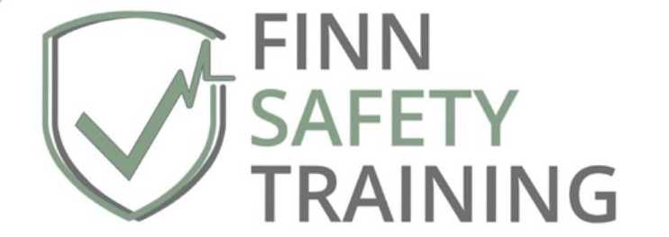

Brochure Of Services

“The training style was engaging and made the learning experience informative and enjoyable.” (Lexie, N.)

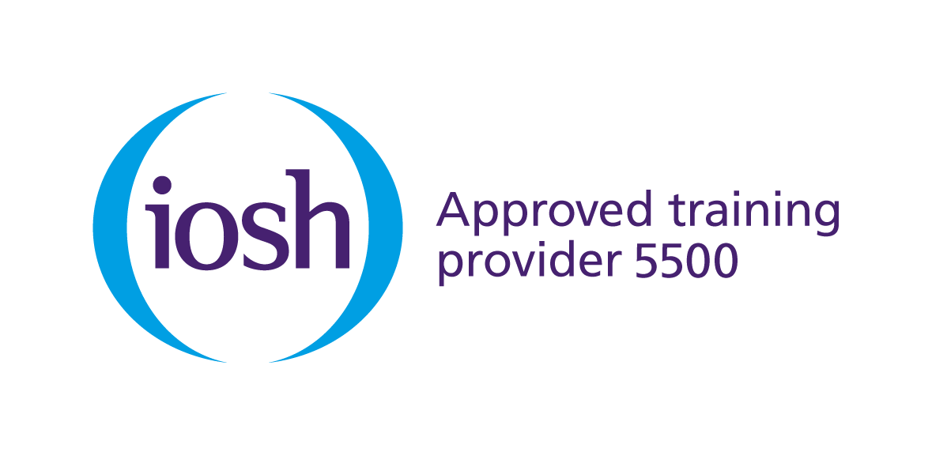

Contents
About Us 3
Meet The Trainer 3
Choosing Your Safety And First Aid Training Course 3
Occupational Health And Safety Course Details 4
IOSH Working Safely 5
IOSH Managing Occupational Health And Wellbeing 5
IOSH Managing Safely 6
IOSH Course Price List 7
First Aid Essentials Course Details 8
Emergency First Aid At Work 8
Emergency Paediatric First Aid 9
Paediatric First Aid 10
First Aid At Work 11
FIRST AID Course Price List 12
Frequently Asked Questions 12
Contact Us 14

TRAINING brochure

About Us
Finn Safety Training provides safety training, consultancy and one to one business support in Exeter and the Southwest area. We are proud to be an approved training provider for the Institute of Occupational Safety and Health (IOSH) delivering a range of occupational health and safety course tailored to your sector. All courses we offer can be delivered flexibly, either in-person, or via virtual classroom settings.

Meet The Trainer

Kristin Finn is the founder and lead trainer for Finn Safety Training. An experienced educator and safety trainer, Kristin is a professional member of IOSH and the First Aid Industry Body, and spent more than 15 years as a lecturer for Plymouth Business School, University of Plymouth, specialising in live event safety, crisis and emergency management. During her time there, she also delivered IOSH training to internal cohorts.
Kristin holds a PhD in Crowd Dynamics and Managing Event Safety, a NEBOSH General Certificate, a Diploma in Crowd Risk Analysis, and is a qualified First Aid Trainer and Assessor. Over the years, her passion for event safety and emergency preparedness has led her to collaborate and engage with key event safety practitioners across the UK and she has been involved in live event delivery.
As an experienced trainer, Kristin has a warm, engaging teaching style and is a firm believer in creating confidence-inspiring, memorable learning experiences. She brings extensive experience of in-person and virtual classroom delivery and was involved in University quality assurance procedures and processes – experience that underpins the quality of training delivered throughout the courses we offer today.

Choosing Your Workplace Safety Training Course
We understand the pressures that businesses face in the current operating climate, in terms of the time commitments involved in undertaking training, and costs. It is our belief that safety training should be both accessible, and affordable. Our training offer is designed with flexibility in mind, to suit your individual business needs.
We offer a range of one day and three-day training courses. All courses can be taken face to face, in a classroom setting. We provide the venue for public courses, or for large enough private groups, we can also come to your site.
For IOSH courses, in addition to the traditional classroom option, we also offer remote online delivery via a ‘Virtual Classroom’ setting, delivered over Teams. All training and assessments are delivered remotely providing greater flexibility for provision of training to multi-site teams and those who work from home.
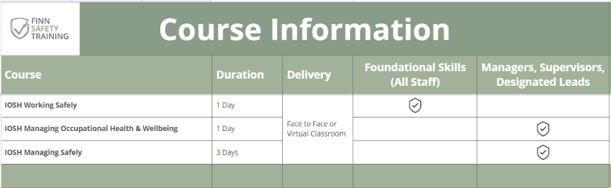

Occupational Health And Safety Course Details
The Institute of Occupational Safety and Health (IOSH) accredits our occupational health and safety courses. To find out more about the individual courses we offer, review the information below for course timings, particulars, and prices.

IOSH Working Safely
Benefits to the organisation
audience: Staff
Duration: one Day
Content
- Introducing Working Safely
- Defining hazard and risk
- Identifying common hazards
- Improving safety performance
IOSH Working Safely® aims to inspire workers to engage with health and safety at work. It’s a high-impact programme designed to be fun and get people fully involved. Because the training is enjoyable and stimulating, the course communicates vital safety and health messages in ways that are memorable.
Benefits to the organisation
- Increased worker awareness of hazard and risk
- Improved understanding of individual and collective responsibility for safety and health
- Positive changes to safety and health behaviour
- Improved productivity and performance
This course is for people working in any sector, at any level, who need a grounding in the essentials of safety and health. Everyone at work should understand why they must work safely. The course demonstrates why everyone – individually and collectively – has a responsibility for health and safety in the workplace.

for safety

IOSH Managing Occupational Health And Wellbeing

Audience: MANAGERS, SUPERVISORS, DESIGNATED LEADS
Duration: one Day
Content
- A healthy company
- Health risk assessment
- Fitness for work
- Wellbeing
Health and wellbeing are a strategic consideration for businesses. Increasingly organisations need to focus not only on what they do but how they do it. Sickness absence due to mental ill health alone is extremely costly. According to the World Health Organisation, 15% of working age adults worldwide in 2019 had a mental disorder, leading to an estimated 12 billion working days lost every year to depression and anxiety. That’s around two and a half days’ mental health absence for each worker globally. A healthy organisation is more likely to be productive, innovative, and competitive.
Managing occupational health and wellbeing explores the range of work and non-work-related illnesses and how these can have an impact. Recognising that managing occupational health needs a collaborative approach, it looks at how to obtain expert help and understand the types of assistance available – internally and externally. H
Benefits to the organisation
- Managers better equipped to be effective in a modern workplace
- Improved, organisation-wide health awareness and appreciation for occupational health
- Fewer hours lost due to ill-health and reduced presenteeism
- A healthier and more productive workplace
- Proactive staff involvement to improve the workplace

al Benefits to the organisation

IOSH Managing Safely

audience: Managers, Supervisors, Designated Leads
Duration: THREE DAYS
Content
- Introducing Managing Safely
- Assessing risks
- Controlling risks
- Understanding responsibilities
- Understanding hazards
- Investigating incidents
- Measuring performance
IOSH Managing Safely® applies to managers and supervisors in all industrial sectors, in organisations of any size. It highlights why safety and health is such an important part of their job. It is designed to bring managers up to speed on the practical actions they need to take to handle safety and health in their teams. By ensuring workers are not only safe and healthy but also contented and fulfilled, organisations can gain a reputation for being good employers, able to attract talent and loyalty.
Benefits to the organisation
- Fewer hours lost due to sickness and accidents, resulting in greater productivity
- Improved, company-wide safety awareness culture and appreciation for health and safety
- Proactive staff involvement in improving the workplace
- Enhanced reputation in the supply chain
- Increased ability to recruit and retain staff
This course shows how occupational safety and health is not just a nice-to-have, but a key element of business management, that contributes to a positive workforce culture and a sustainable business.

IOSH Course Price List
We believe in making safety training both accessible, and affordable. Our IOSH training offer is designed with flexibility in mind, to suit your individual business needs, and our courses can be tailored to your sector. If you would like to make use of our small group or large group (private course) discounts, please quote the offer and number of learners at point of enquiry.
To discuss available dates, contact us: bookingenquiries@finnsafetytraining.co.uk
IOSH Course Information and Prices  NB: Refreshers recommended every 3 years | Price per learner | Group Offers
 | Price per learner | Small Grp  (3-7) | Large Grp (8+)*
Working Safely ® (1 Day)
In-person / Classroom Venue | £175 | £160  per learner | £1200  per group
Online – Virtual Classroom | £160 | £145  per learner | £1100  per group
Managing Occupational Health & Wellbeing (1 Day)
In-person / Classroom Venue | £175 | £160  per learner | £1200  per group
Online – Virtual Classroom | £160 | £145  per learner | £1100  per group
Managing Safely® (3 Days)
In-person / Classroom Venue | £475 | £425  per learner | £3200  per group
Online – Virtual Classroom | £450 | £400  per learner | £3000  per group
*For larger groups of 8 or more, we can deliver a private course at your venue, or online.
NB: Large Group price stated is based on 8 learners. Total price per large group is dependent on number of delegates, location, and course materials required. (Up to a max. of 20 private learners may be accommodated in one large group cohort)

First Aid Training
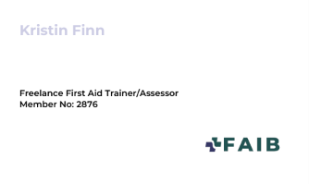
As a First Aid Trainer and Assessor for the FAIB (First Aid Industry Body), workplace first aid training, and baby and child awareness classes can be provided through collaboration with Mini First Aid Dorset, Somerset and North Devon. Get in touch via info@finnsafetytraining.co.uk for more information.

Emergency First Aid At Work
Benefits to the organisation
audience: Staff
Duration: one Day
Content
- Role and responsibilities of a first aider
- Managing an unresponsive casualty who is not breathing normally
- Managing a casualty who is in shock
- How to assess an incident
- Recognising and assisting a casualty who is choking
- Managing a casualty with a minor injury
- Managing an unresponsive casualty who is breathing normally
- Managing a casualty with external bleeding
Individuals and organisations are advised to take an Emergency First Aid at Work (EFAW) course to provide and deliver first aid skills within their workplaces. It covers a range of CPR and emergency first aid skills. Candidates must be a minimum of 16-years-old at the time of taking the EFAW assessment, and no prior first aid knowledge is required. It would suit all staff working in a lower risk environment or who are not the designated first aid lead.
EFAW is a 6-hour course that is trainer assessed and can be delivered in-person, or via blended learning, for greater flexibility. It comprises of practical and theoretical work. There is a practical assessment on CPR and first aid, and all assessment criteria must be achieved to pass the course. Upon qualifying, the EFAW certificate is valid for 3 years. To renew, candidates must re-qualify by being assessed against all learning outcomes and assessment criteria. A renewal is achieved by redoing the initial 6 hours of course content. The next step is to complete other first aid courses including, First Aid at Work (FAW), Emergency Paediatric First Aid (EPFA), and Paediatric First Aid (PFA).
Benefits to the organisation
- Open to all staff and no prior first aid knowledge is required
- Certificates that are valid for 3 years
- Provides employers and your staff with the skills to reduce the risks and dangers in your workplace
- Promotes a safe working environment and culture

Emergency Paediatric First Aid
Benefits to the organisation
audience: Staff
Duration: one Day
Individuals and organisations are advised to take an Emergency Paediatrics First Aid (EPFA) course to provide and deliver emergency first aid skills to children and infants (babies) within their homes or workplaces. It covers a range of CPR and emergency first aid skills specifically for children and infants (babies) – because their first aid needs differ from those of adults. Candidates must be a minimum of 16-years-old at the time of taking the Emergency Paediatric First Aid assessment, and no prior first aid knowledge is required.
Content
- Understanding the role of the paediatric first aider
- Assessing an emergency situation and acting safely and effectively
- Providing first aid to an infant and a child who is:
- unresponsive and not breathing normally
- unresponsive and breathing normally
- wounded and bleeding
- suffering from shock
- has a foreign body airway obstruction
This course would suit those working in childcare settings who wish to provide paediatric first aid support, but are not the designated paediatric first aid lead, as well as parents and guardians. It is a one day (6 hour) first aid qualification that is delivered in person to comply with the Early Years Framework (EYFS). It is trainer assessed and comprises of practical work and theoretical classroom work. There is a practical assessment on CPR and first aid, and all assessment criteria must be achieved to pass the course. Upon qualifying, the EPFA is valid for three years. To renew, candidates must re-qualify by being assessed against all learning outcomes and assessment criteria. A renewal is achieved by redoing the initial 6 hours of course content. The next step is to complete other first aid courses including, Emergency First Aid at Work (EFAW), First Aid at Work (FAW), and Paediatric First Aid (PFA).
Benefits to the organisation
- Open to all staff and no prior first aid knowledge is required
- Certificates that are valid for 3 years
- Provides employers and your staff with the skills to reduce the risks and dangers in your workplace
- Promotes a safe working environment and culture

Paediatric First Aid
Benefits to the organisation
audience: Staff, Supervisors, designated leads
Duration: two Days
Content (additional to EPFA)
- Understanding of a wide range of specific injuries and medical conditions, as well as how to apply first aid to a child or infant to treat them
The RLSS UK Qualifications Level 3 Paediatric First Aid (PFA) qualification covers a wide range of CPR and first aid skills, equipping the first aider to administer first aid to children and infants (babies).
The two-day Paediatric First Aid qualification is Ofqual, CCEA and Qualification Wales accredited and valid for three years after the date of assessment. It is suitable for anyone who has contact or works with children and infants (babies).
The Paediatric First Aid course content can be covered within 12 hours over two days or a blended learning version of the course is also available. The course comprises practical work and theoretical classroom work, as well as a practical and multiple-choice theory assessment of CPR and first aid.
Upon qualifying, the PFA certificate is valid for 3 years. To renew a Paediatric First Aid certificate, candidates must re-qualify by being assessed against all learning outcomes and assessment criteria for the qualification. A renewal is achieved by redoing the initial 12 hours of course content.
Benefits to the organisation
- Open to all staff and no prior first aid knowledge is required
- Certificates that are valid for 3 years
- Enables employers to meet EYFS requirements
- Provides employers and your staff with the skills to reduce the risks and dangers in your workplace
- Promotes a safe working environment and culture
The next step is to complete other first aid courses including, Emergency First Aid at Work (EFAW), First Aid at Work (FAW), Automated External Defibrillator (AED) Programme or, become First Aid Trainer.

First Aid At Work
Benefits to the organisation
audience: Staff, Supervisors, designated leads
Duration: three Days
Content (additional to EFAW)
- In-depth review of CPR skills
- Broad range of first aid skills
- Understanding of a wide range of specific injuries and medical conditions, as well as how to apply first aid to treat them
Individuals and organisations are advised to take a First Aid at Work course to provide and deliver first aid skills within their workplaces. The First Aid at Work (FAW) course is the most comprehensive first aid training for the workplace. It covers various CPR and first aid skills and equips first aiders with the knowledge to apply first aid to specific injuries and illnesses. It is suitable for all industries and enables employers to meet HSE and HSENI requirements. Candidates must be a minimum of 16-years-old at the time of taking the First Aid at Work assessment, and no prior first aid knowledge is required. This course would suit those working in higher risk workplace environments and those who have responsibility as a designated first aid lead.
The First Aid at Work (FAW) course is 18 hours in length and can be delivered over three consecutive days either in-person or via blended learning. The FAW course comprises practical classroom work and theoretical work, as well as a practical and multiple-choice theory assessment of CPR and first aid. Upon qualifying, the FAW certificate is valid for 3 years.
The First Aid at Work (FAW) qualification expires three years after the date on the certificate. Candidates must re-qualify before the expiry date of their existing qualification. If you fail to requalify prior to the expiry date of your existing certificate, you may still be able to requalify by successfully completing a two-day First Aid at Work requalification course within 28 days (following your qualification expiry date). NB: you are not permitted to act as a first aider until you have requalified.To re-qualify, you must complete a 12-hour renewal course and be assessed against all learning outcomes and assessment criteria. This can be achieved over two days in-person, or a blended learning version of the renewal course is also available.
Benefits to the organisation
- Open to all staff and no prior first aid knowledge is required
- Certificates that are valid for 3 years
- Enables employers to meet HSE requirements
- Provides employers and your staff with the skills to reduce the risks and dangers in your workplace
- Promotes a safe working environment and culture
The next step is to complete other first aid courses including, Emergency Paediatric First Aid (EPFA), Paediatric First Aid (PFA), Automated External Defibrillator (AED) Programme or, become First Aid Trainer.

FIRST AID Course Prices
All prices for first aid training can be found via the Mini First Aid Dorset, Somerset or North Devon websites, and open course places can be booked directly via the website. Get in touch if you would like to discuss delivery of a private course.
To discuss available dates, contact us: bookingenquiries@finnsafetytraining.co.uk

Non-Accredited training, and one-to-one business support
With over 25 years’ experience in consultancy, course design and delivery in the safety, business management, organisational and cultural change fields, we are perfectly placed to design and deliver bespoke non-accredited workshops, staff briefings, and practical sessions to support your team's safety skills development and workplace awareness needs.
We can also offer regular, retained one to one advice, guidance and support as an outsourced critical friend around safety management planning, risk assessment, operational procedures, organisational skills development, training needs assessment, and strategic growth, to help your business develop, grow and prioritise safety in the workplace.
Send us an email at info@finnsafetytraining.co.uk to book in for a free 30-minute discovery chat.

Frequently Asked Questions
If you are considering booking a course, here is some general information that applies to most of our training. If you have any further questions, then give us a call.

How do I book onto a course?
You can find out about available course dates and book onto one of our courses by email (bookingenquiries@finnsafetytraining.co.uk) or by giving us a call on 07930 366 435.

What should I bring to my virtual / in-person training?
Just yourself, some ID for course registration, a pen, and (for virtual courses only) a laptop with good internet access. We provide all course-related materials linked to your training.

Do I need specialist software to access online IOSH training, or first aid e-learning?
No, you don’t. Upon enrolment, you will receive an email that includes the Teams meeting invite(s) for online IOSH training days, or the signup information for the first aid blended e-learning platform. You will then be able to remotely join your IOSH training course online, or to work through the required first aid e-learning modules at your own pace, ahead of the in-person practical learning associated with your course. Please note that the e-learning must be completed before you attend the face to face training.

How large are the class sizes?
For IOSH training, typical class sizes are between 4 to 8 people, although we can accommodate up to 20 individuals maximum in one cohort. Most classes for first aid training are between 6-8 people, although we can accommodate up to 12 individuals in one cohort.

What happens if a course is cancelled?
We do not cancel courses lightly. If a course has to be cancelled, we will call all participants as soon as we can to rearrange the training.

What happens if I am unable to make it on one, or more, of the days I must attend?
Please let us know as soon as possible if you will be late, or unable to attend. A few minutes late may be ok, but due to the modules that must be completed to take the assessments, your training may need to be rebooked. If it can be avoided, it is best not to miss any of the training if at all possible.

What should I wear for first aid training?
It is advised you wear something comfortable, such as trousers, and t-shirt, or jumper. Practical tasks require you simulate and treat injuries or medical incidents, so may require you to kneel or lie down. Bringing a knee rest could be more comfortable for floor work.

What is the split between online and in-person training on a blended first aid course?
This depends on the course chosen. It is designed to make the training experience more flexible, with less time out of the office for practical training and assessment, and the option to work through e-learning at your own pace. The online and face to face split is roughly:
- Emergency First Aid at Work EFAW – 1 Day (6 hrs): 3 hrs e-learning & 3 hrs in-person
- Paediatric First Aid (PFA) – 2 Days (12 hrs): 6 hrs e-learning & 6 hrs in-person
- First Aid at Work (FAW) – 3 Days (18 hours): 6 hrs e-learning & 12 hrs in-person
Please note that the Emergency Paediatric First Aid (EPFA) cannot be taken via blended learning as EYFS requirements state that it must be completed in-person only.

Contact Us
If you are interested in finding out more about the courses and services we offer, have an interest in something specific that isn’t listed, or you would like to discuss available training dates, then get in touch with us via one of the methods below:

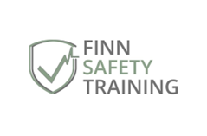
E: bookingenquiries@finnsafetytraining.co.uk
T: +44 7930 366 435
W: www.finnsafetytraining.co.uk

We look forward to hearing from you soon!

